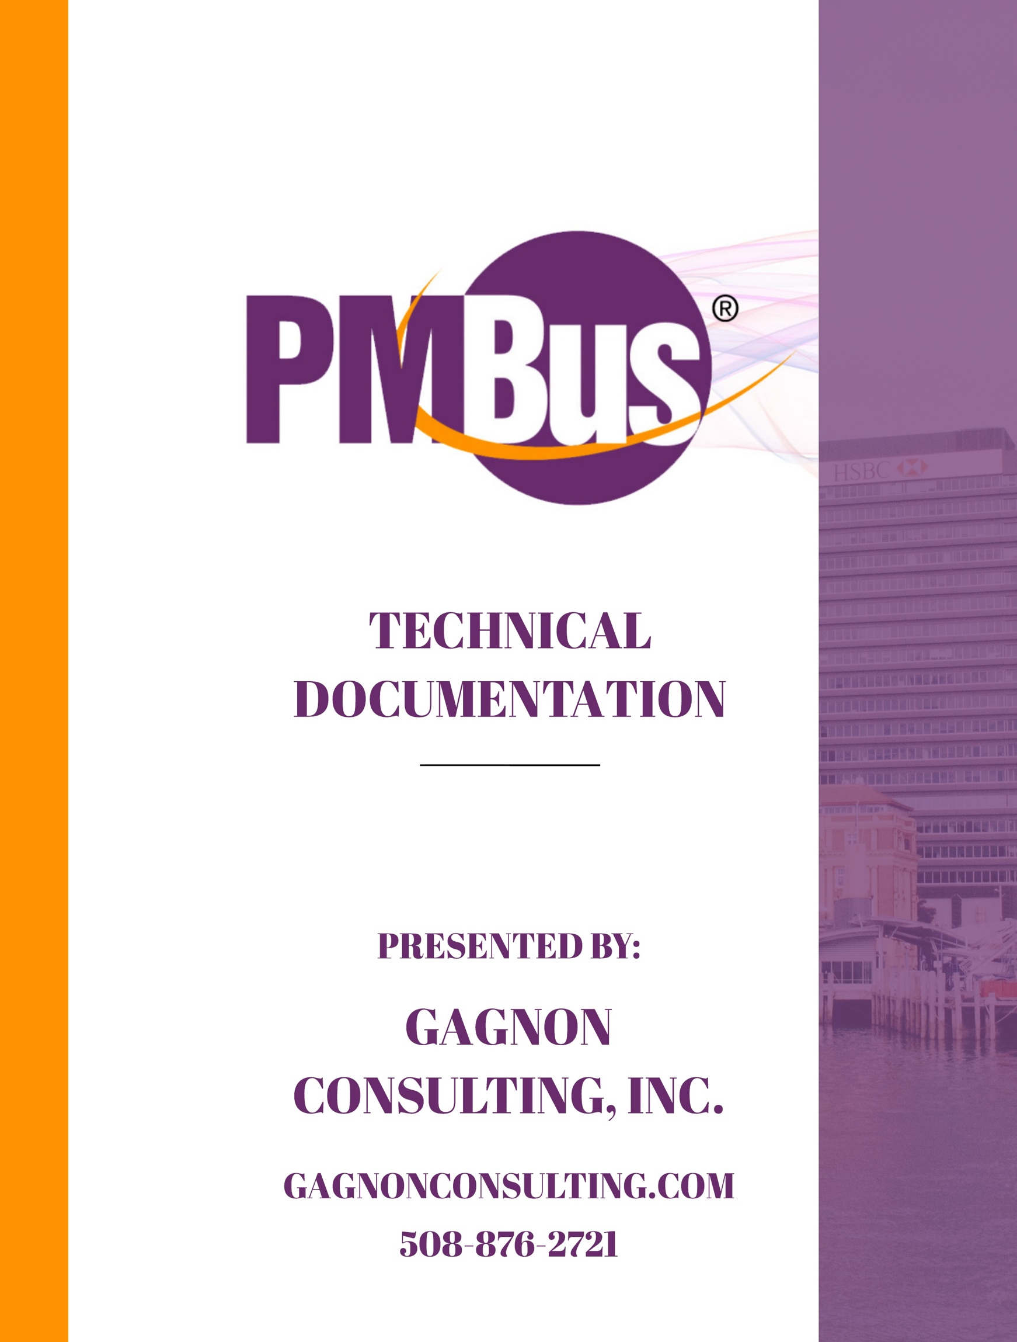

Table of Contents

1. Executive Summary 4

2. Hosting Platform 4

3. Wordpress 4

3.1. Themes: 4

3.2. Plugins: 5

3.2.1. Plugins the Site Requires for Functionality: 5

3.2.2. Plugins the Site Utilizes for Style and Convenience: 6

3.2.3. Plugins Used for Development / Admin Purposes: 6

3.3. Pages 6

3.4. Posts 6

3.5. Users 6

3.6. Shortcodes 6

3.7. Development Best Practice for Wordpress 7

3.7.1. add_action() 7

3.7.2. Remove_action() 7

4. Github 7

4.1. Remote Repository: 8

5. Taxonomies 8

5.1. Companies 8

5.2. Companies Directory (SMIF Member) 9

5.2.1. List Members and Membership type 9

5.2.2. List Members and Product Pages 9

5.3. Company Page: 9

5.4. Company User: 10

6. SMIF Member Pages 10

6.1. Page Parent: 10

6.2. Page Template: 11

7. WooCommerce 11

7.1. Products 12

7.1.1. Products By Category 12

8. Admin Menu 12

# Executive Summary

The PMBus website is running Wordpress Version 4.9.8 and utilizes a production, staging and local development environment. This offers flexibility, performance and security as well requiring very little maintenance moving forward. The sites architecture runs off of the Divi theme by Elegant Themes. A child theme has been implemented to preserve all functionality customization as updates emanate in the future.

Custom functionality and development takes place in the local environment while the staging site allows for appearance adjustments and content creation such as pages, posts, articles and more. All development is documented and tracked using GitHub’s version control system.

* Wordpress - Version 4.9.8
* Divi – [Parent Theme]

<https://www.elegantthemes.com/gallery/divi/>

* PMBus – [Child Theme of Divi]
* Github - Version Control
* Development Environments
  + Local
  + Staging
  + Production

# Hosting Platform

Using WPEngine virtual server hosting. Provides both staging and production environments, backups, site deployment from staging to live, and live to staging, and real time 24/7 tech support.

# Wordpress

Wordpress is an open source content management system based in PHP and MySQL. It primarily utilizes themes and plugins for site customization and functionality. Codex can be found <https://codex.wordpress.org/>

## Themes:

By installing a theme on a Wordpress site, the developer may alter the functionality and style without altering its core content such as users and pages or the database. This allows the core to be updated without disturbing changes made using a theme.

By creating a child theme of the active parent Divi theme, all customization will persist as the site undergoes updates in the future. This allows the parent theme and Wordpress core to be updated without disturbing custom coding done in the child theme. Note: All custom code is done in the child theme.

* Divi [Parent Theme]

<https://www.elegantthemes.com/gallery/divi/>

* PMBus [Child Theme of Divi]

To enable the child themes stylesheet to load last we enqueue it in:

(Enqueue is wordpress’s way of efficiently loading JS and CSS files without adding them to the head of each individual page)

/includes/gci_styles_enqueue.php

## Plugins:

Wordpress’s built in plugin architecture allows further extension of functionality through the use of plugins. Plugins can be activated and deactivated in the admin panel of the site.

### Plugins the Site Requires for Functionality:

* Advanced Custom Fields:

Add custom fields of data to users, pages, companies ect…for later user throughout site.

* Co-Authors Plus:

Allows multiple Company Admin users to edit a company page.

* Capability Manager Enhanced:

Extends capabilities for roles allowing permission adjustments for users.

* Gravity Forms*:

Forms submissions, user registration ect…

* Gravity Forms User Registration Add-On:

Extends gravity forms functionality to allow user registration.

* Groups*:

Permission control for user types such as Company Admin, SMIF Tool, SMIF Full members.

* Login With Ajax:

Allows users to login.

* WooCommerce:

Product infrastructure.

<https://docs.woocommerce.com/documentation/plugins/woocommerce/woocommerce-codex/>

* Image Horizontal Reel Scroll Slideshow:

Scrolling logos on home page.

* WooCommerce Collapsing Categories:

Sidebar display of product categories.

### Plugins the Site Utilizes for Style and Convenience:

* Akismet Anti-Spam
* Advanced WooSearch
* Demo Tax Meta Class
* Duplicate Page
* Featured Product by Category
* Radio Buttons for Taxonomies
* Styler for Gravity Forms
* Updraft Plus*

### Plugins Used for Development / Admin Purposes:

* One Click Child Theme
* Debug Bar
* Debug Bar List Script & Style Dependencies
* Enable Media Replace
* WP Pusher

## Pages

## Posts

## Users

## Shortcodes

Shortcodes are php custom functions called in various locations in Wordpress using square brackets [shortcode_name] once the function has been added as a shortcode using:

add_shortcode (‘function_name’, ‘desired_shortcode_name’);

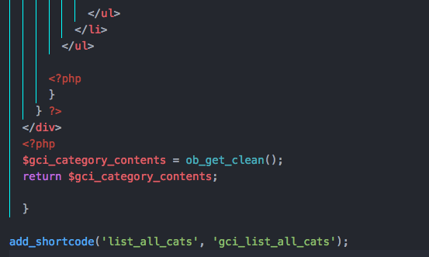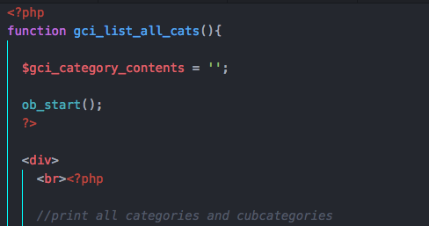

Start of Function End of Function

To use this shortcode insert ‘[list_all_cats]’ in the html of the desired page.

See Wordpress codex for further shortcode usage, details and documentation.

## Development Best Practice for Wordpress

Through the custom development of the PMBus site, in cases where default Wordpress functionality required adjustment, the following functions were used. This is considered best practice for development using Wordpress. See Wordpress codex for further usage, details and documentation.

### add_action()

Actions are the hooks that the WordPress core launches at specific points during execution, or when specific events occur. Plugins can specify that one or more of its PHP functions are executed at these points, using the Action API.

### Remove_action()

This function removes a function attached to a specified action hook. This method can be used to remove default functions attached to a specific action hook and possibly replace them with a substitute.

# Github

GitHub is a web-based hosting service for version control using Git. Utilized features include distributed version control and source code management (SCM) functionality of Git as well as access control and bug tracking.

All functionality is developed and tested on the **local environment**. Once a function or theme adjustment is complete it is pushed to the remote Git repository which triggers a webhook to update the theme on the **staging site**. This is done using the plugin **WP Pusher** and ensures the staging site along with anyone working with the repository is up to date.

## Remote Repository:

<https://github.com/tgiordani/PMBus>

# Taxonomies

Wordpress has a pre-built with a categorical hierarchy made up of ‘**taxonomies**’. These are nothing more than a way to categorize posts, pages, products and so on as well as store data that differentiates them from one another.

## Companies

For the PMBus site, a new taxonomy was created called ’**Companies**’ with each Company that is a member of the site being a term. We can attribute pages, users and products to a single term (or instance of a company taxonomy).

Example…

**Companies**  <– Taxonomy

-Intel <– Taxonomy Term [Instance of Companies]

-Texas Instruments <– Taxonomy Term [Instance of Companies]

**Creating Companies:**

In order to create a new taxonomy and allow data to be saved, a new taxonomy had to be registered.

/includes/company_taxonomy.php

The plugin **Advanced Custom Fields** is required to save the additional fields for a given company. The membership type meta data for each company is used when displaying the company in the products by company and members directory tables. See shortcodes for more details.

* Membership Type
* Company Website URL
* Addictional Information

## Companies Directory (SMIF Member)

### List Members and Membership type

A custom query is used to check the DB for all members. Based on this list the external url meta field saved to the company is also pulled to wrap the name of the company in the list. Custom meta field Membership Type is also grabbed to be displayed in column two. Finally the companies internal PMBus product page link is pulled and wrapped in the third column.

Using javascript and css the table that is displayed of members is given a searchable functionality. Showing only the members who match the searched text and display=none to the rows who’s company does not match. The shortcode is called on the page it is to be displayed on. The shortcode is created on:

/includes/shortcodes/list_pmbus_members.php

### List Members and Product Pages

Listing the companies with pages, and corresponding links to those pages is done with a similar query. This time however, there is a check to see if the company is a tools member, or drafted member. If so, that company will not be displayed in this list. Instead of the membership type, here the custom meta field data ‘additional info’ will be displayed. Example: ‘Formerly known as Company X…’

/includes/shortcodes/products_by_company.php

## Company Page:

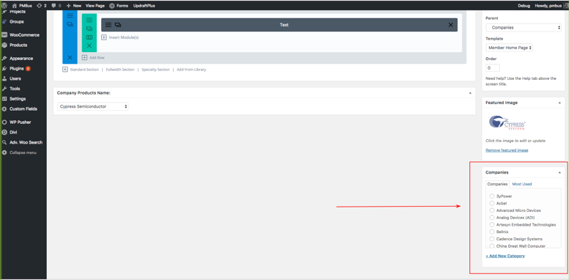Each Page now has the option to select what Company it belongs to. This can be found on the bottom right of a page in the admin page editor. See diagram to the left.

## Company User:

Each User also has the option to select what company it belongs to. This can be found below the groups input on both the create new user and edit user page. Note only companies currently in the list are selectable in the dropdown. See diagram below.

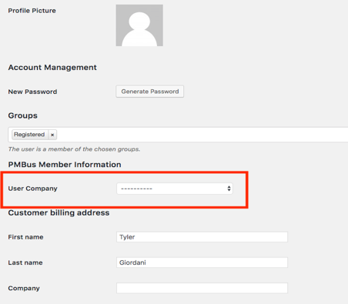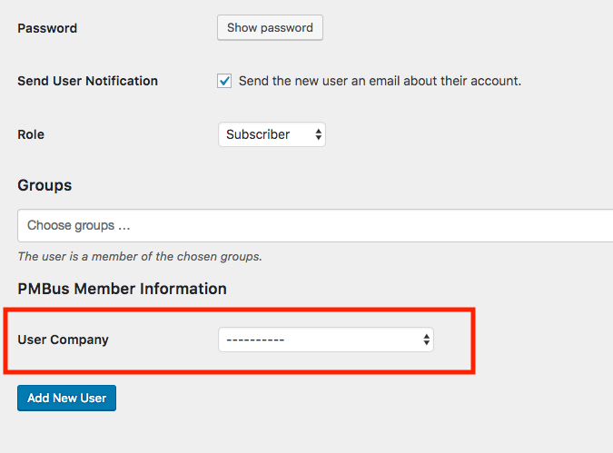

# SMIF Member Pages

Each PMBus Adopter and SMIF Full member has a page on the PMBus site that displays corresponding products and logo with a brief description. When creating a new page in Wordpress, by default the parent is set to ‘null’ and the page template set to ‘Default Template’.

## Page Parent:

The PMBus child theme enables new pages, to have a parent value of ‘Companies’ which is a level below ‘Directory’. This does not overwrite pages whose parent is already set, and can be changed to a different parent within the page.

/includes/members_pages/set_parent_default.php

Example…

**Directory** <-- Category [Parent Category]

-**Companies** <-- Category [Child of **Directory**, Parent of Intel/TI]

-Intel <-- Page [Child of Companies]

-Texas Instruments <-- page [Child of Companies]

## Page Template:

The PMBus child theme enables new pages when created, to set the template value to ‘Member Home Page’. This does not overwrite pages whose template is already defined, and can be changed to a different template within the page.

/includes/members_pages/page_template_default.php

The **Member Home Page** template retrieves the featured image set for that page (logo) and displays the image in the center of the page. Below this, is where any changes made using the WordPress page editor will display. Under any page edits made in the admin pane (including description) the companies products will display in a tabular format. Featured products will be displayed in a table above a full list of all products broken up by category. A custom query is used to retrieve all categories that include products from the defined company, and display all products in each category, with one table of products per category. This template includes a collapsible sidebar display of all product categories.

/member_home_page.php

For non-member pages that will display the same sidebar, a template was created without the product query above. This will include any content edits made in the admin page editor / Divi builder.

/sidebar_display.php

# WooCommerce

WooCommerce is a plugin that is responsible for all of the products on the PMBus site. The plugin has built in attributes and objects such as categories and products. This allows users to create, edit, display and delete products as well as define what company the products belong to and whether or not the product is featured. Some WooCommerce functionality was removed such as related products, individual product pages, product count and product below:

/includes/gci_woocommerce_removals.php

By default, products display in a grid format. Customization was required to alter its display into a tabular format. WooCommerce uses a loop to display products, thus adjustments were made:

/woocommerce/loop-start.php

/woocommerce/loop-end.php

The loop was altered, to create a table upon start (loop-start.php) and close the table once the loop finished (loop-end.php). Adjustments were also made to the product display, from 2-4 columns, to a single column with a product table no longer displaying in a grid format. Each attribute of a product displayed is now given a row in the table, and a column in its corresponding row for the product image, company, product name, description and link to offsite page for that product. This was done in:

/includes/gci_show_product_info.php

/includes/single_column_product_display.php

## Products

WooCommerce comes prebuilt with a product display structure. All categories can be searched and displayed (including company) and have their own page structure. Using defined shortcodes, products of specified categories can be displayed such as company member pages.

### Products By Category

Using Wordpress’s prebuild get_terms() function all product parent categories were retrieved. Then a for each loop was run to go through each parent category and display its children categories. This is done in:

/includes/shortcodes/products_by_category.php

Similarly all products by categories uses the same structure except during the for each loop, a shortcode is run to retrieve all products in the current category of the loop, done in:

/includes/shortcodes/list_all_products.php

# Admin Menu

The PMBus custom admin menu utilizes WordPress’s core admin menu with customization for the PMBus admin user. A number of unnecessary links have been removed such as plugin links, WPEngine dashboard link, Options, Tools and all other links not needed by the PMBus admin. This reduces clutter and only displays what will be needed by the admin user. Likewise, a custom link was added for the PMBus Members linking to the Companies Taxonomy directory add / edit page.

/includes/admin_menu/add_pmbus_admin_menu.php